**INPUTS :** a = 0 , b = 2pi/3, intervals = 10

**FUNCTIONS :**

***integral*** – **Input:** upper limit , lower limit, intervals.

**Output:** list of convergent value of sin and cos function for trapezoidal rule, Simpson 1/3 rule and Simpson 3/8 rule.

***sine , cosine***  – **Input:** degree value **Output: sin(**degree value**)**

***converge*** – **Input:** list of float values **Output :** convergent term index

**EXPECTED OUTPUT :**

***Y*** = integral of sin x from 0° to 120° = (-cos(120°)) - (-cos(0°))

= (-0.5) – (-1) = 0.5 + 1 = ***1.5000***

***Y1*** = integral of cos x from 0° to 120° = sin(120°) – sin(0°)

= 0.8660 – 0 = ***0.8660***

**PLOTS & OUTPUT :**

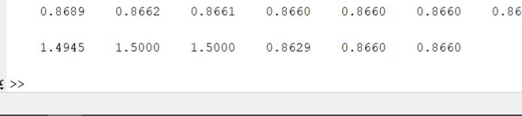

The first 3 values are the 10 intervals value of trapezoidal rule, Simpson 1/3 rule and Simpson 3/8 rule for ***y = sin x*** with b =120° and a = 0°.

The Next 3 values are the 10 intervals value of trapezoidal rule, Simpson 1/3 rule and Simpson 3/8 rule for ***y = cos x*** with b =120° and a = 0°.

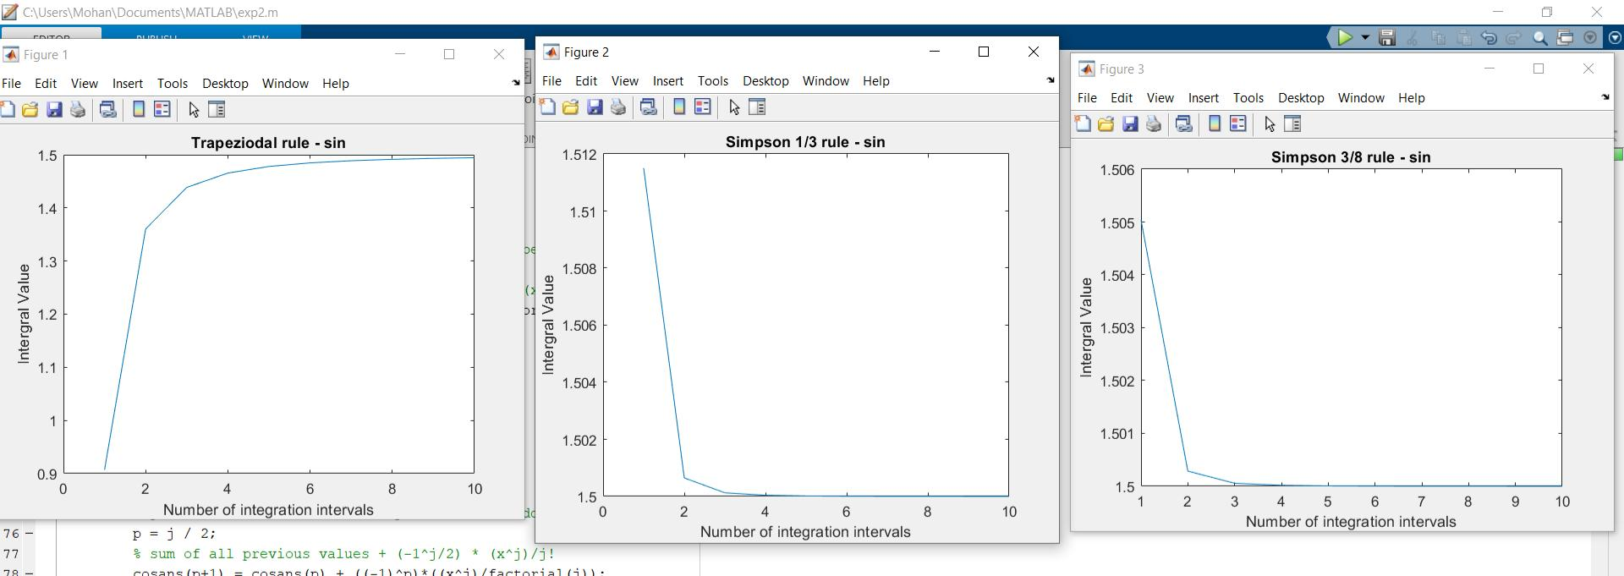

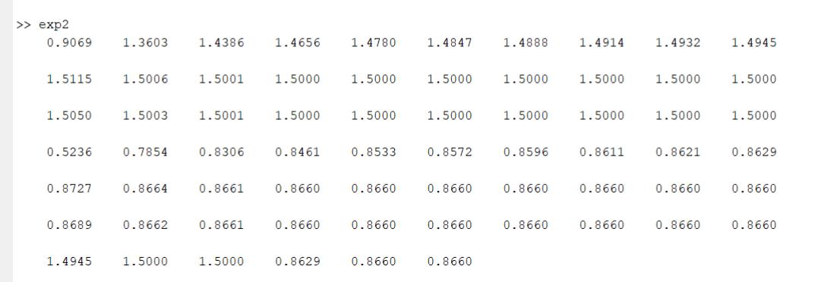

The trapezoidal rule took 10 intervals did not converged to expected output.





The Simpson 1/3 rule took less intervals than trapezoidal rule and converged to expected output within 10 intervals while trapezoidal rule didn’t.



For 1 interval in Simpson 1/3 rule and Simpson 3/8 rule, the value converged more in Simpson 3/8 rule than Simpson 1/3 rule.

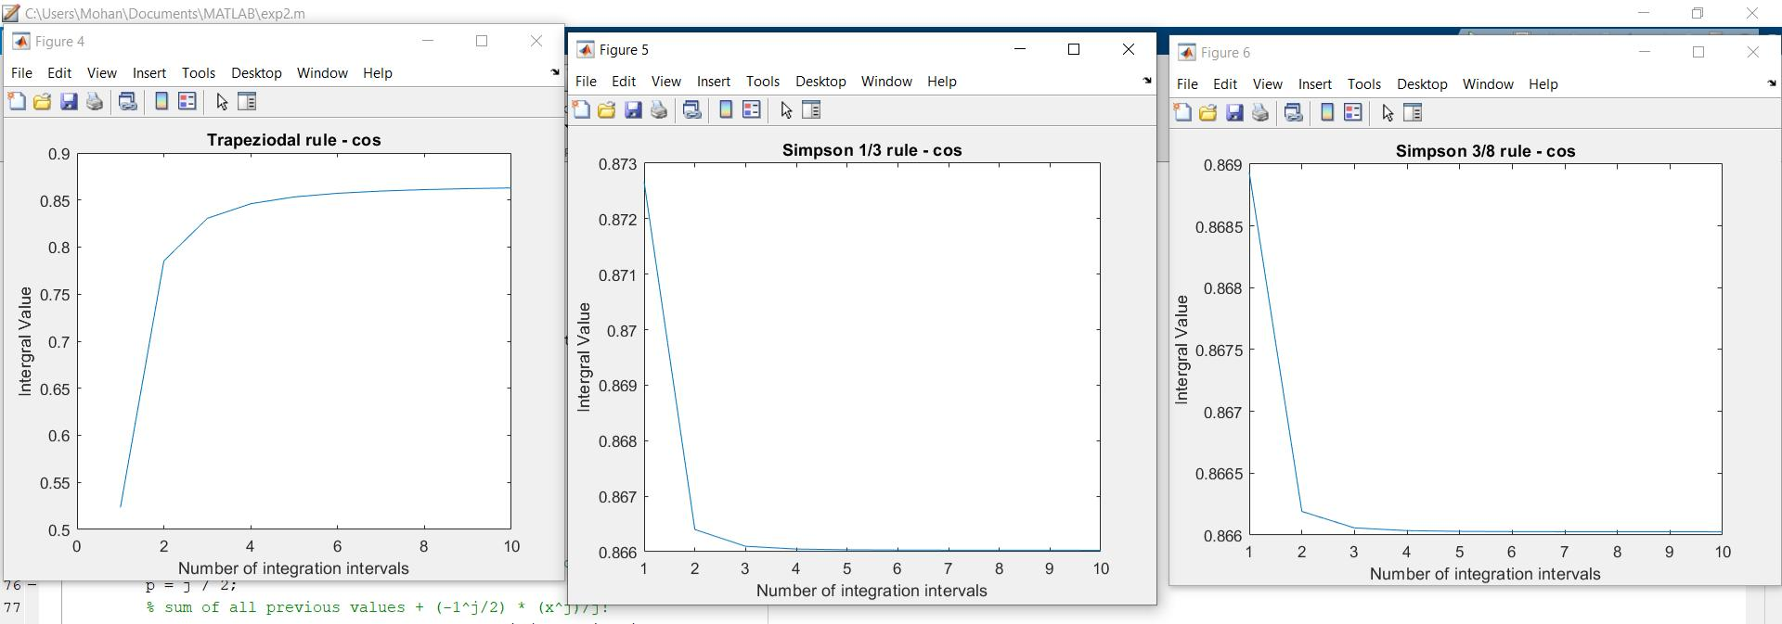



The trapezoidal rule took 10 intervals did not converged to expected output.



The Simpson 1/3 rule took less intervals than trapezoidal rule and converged to expected output with 10 intervals while trapezoidal rule didn’t.





For 1 interval in Simpson 1/3 rule and Simpson 3/8 rule, the value converged more in Simpson 3/8 rule than Simpson 1/3 rule.